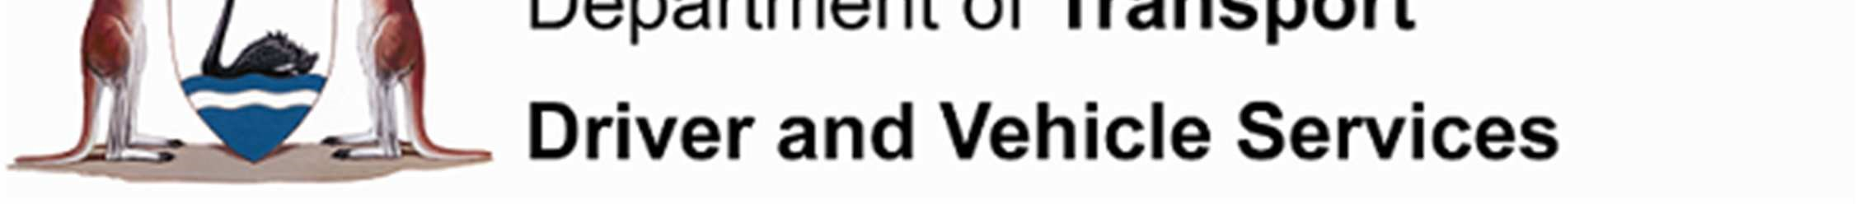
Our Ref: 46-2017-1837
Enquires: AJ Mathota

Mr John Castel
Horizon Power
18 Brodie Hall Drive
BENTLEY WA 6102

Application for an Exemption from Road Traffic Code 2000 Regulations 233

Dear Mr Castel

Thank you for the application to Vehicle Safety and Standards submitted for an exemption from certain requirements of the Road Traffic Code 2000 pertaining when people travel in elevated working platforms of some of the Regional Power Corporation vehicles trading as Horizon Power vehicles.

The Road Traffic Code 2000 prohibits persons from riding in or on a motor vehicle in the goods section of an open load space, and without proper restraints.

Your application seeks exemptions to permit members of the Horizon Power service crew to travel in the goods section of an open load space or basket in elevated working platforms when the vehicle is travelling for the purpose of providing service to operation, maintenance and repair of the power lines. Following assessment of your application, and under the provisions of Road Traffic Code 2000, I am pleased to advise you that an exemption can be granted.

Please note that you are required to ensure that all persons involved are aware of the exemption and its conditions. Duty of Care to any person who operates the vehicle requires you to advise them of the provisions that may affect them.

In addition you must also be aware of the general provisions of the Road Traffic Act and the Road Traffic Code 2000 and that you must ensure that you, drivers of the vehicles, Horizon Power employees and Horizon Power contracted service providers employees, and any other persons involved in providing escort services to over height vehicles are familiar with these provisions. Duty of care to your employees and fellow workers requires
DoT Reference No : 46-2017-1837 GPO Box R1290 Perth, Western Australia, 6844 Issued 14 November 2017 Telephone: 13 11 56 Fax: 1300 669 995
Page 1 of 2 www.transport.wa.gov.au/dvs ABN 27 285 643 255
you to advise them of the provisions that may affect them. This would include, but is not limited to, considerations such as consumption of alcohol, limbs protruding from the vehicle and other behavioural considerations.

So that enforcement officers may inspect compliance with the legislation and the attached conditions of approval, it is required that a copy of this letter and of the exemption be carried in the vehicle at all times.

If you have any further queries concerning the above please contact AJ Mathota on 08-9216 3891.

Your concern for road safety in Western Australia is appreciated and I trust that the providing service to operation, maintenance and repair of the power lines by Horizon Power proves to be a successful and above all safe event.

Yours sincerely
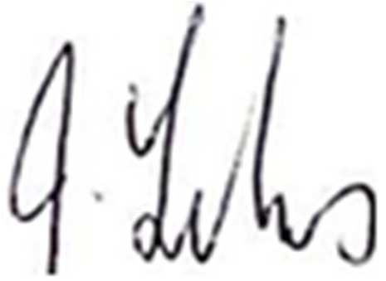

Jim Felvus Manager Vehicle Operations

14 November, 2017

DoT Reference No : 46-2017-1837 | GPO Box R1290 Perth, Western Australia, 6844
Issued 14 November 2017 | Telephone: 13 11 56 Fax: 1300 669 995
Page 2 of 2 | www.transport.wa.gov.au/dvs ABN 27 285 643 255

Our Ref: 46-2017-1837
Enquires: AJ Mathota

Exemption from the Road Traffic Code 2000, Part 16, Division 2
Pursuant to Part 16, Division 4 of the Road Traffic Code 2000, and subject to the conditions detailed below, I, Jim Felvus, Manager Vehicle Operations, delegate to Chief Executive Officer of the Department of Transport, hereby grant the following exemption from Part 16, Division 2 of the Road Traffic Code 2000.
Persons engaged, on behalf of Horizon Power and Horizon Power contracted services providing service to operation, maintenance and repair of the power lines referred to in Horizon Power correspondence are exempted from the provisions of Regulation 233 whilst carrying out such activities in accordance with the conditions of this exemption.

Exemption
Persons engaged in providing service to operation, maintenance and repair of the power lines, organised by Horizon Power and Horizon Power contracted services, hereinafter referred to as the event, the vehicles approved by the organisers and listed in below table 1, hereinafter referred to as the vehicle are exempted from the Part 16, Division 2, Rule 233 of the Road Traffic Code 2000 in accordance with the conditions listed.
Table 1
  Serial  No | Vehicle Identification or Chassis Number
  1. | JALFTS34LB7000376
  2. | JALFTS34L87000230
  3. | WMAN36ZZXDY29681
  4. | WMAL90ZZ64Y129116
  5. | JALFSS90JB7000080
  6. | JALFTS34H47000238
  7. | WMAN36ZZ7DY297019
  8. | JALFSS90JD7000010
  Serial  No | Vehicle Identification or Chassis Number
  9. | JALFTS34LG7000055
  10. | JALFVZ34SG7000012
  11. | JALFSS90JF7000050
  12. | JALFVZ34SE7000264
  13. | JALFVZ34SE7000262
  14. | JALFVZ34SE7000146
  15. | JALFTS34LG7000224

Conditions
2.1. Horizon Power shall nominate a person who has overall responsibility for Horizon Power and Horizon Power contracted services vehicles operations. This person shall ensure that the requirements of this exemption are met at all times and shall have authority to delegate such responsibilities as they may
DoT Reference No : 46-2017-1837 GPO Box R1290 Perth, Western Australia, 6844 Issued 14 November 2017 Telephone: 13 11 56 Fax: 1300 669 995
Page 1 of 3 www.transport.wa.gov.au/dvs ABN 27 285 643 255
deem necessary. Such delegated responsibilities may include but not be limited to, dispatch of vehicles and record keeping.
2.2. Horizon Power and Horizon Power contracted services vehicles and persons engaged must comply with requirements of Australian Standards, AS 2550.10 for Cranes, hoists and winches – Safe use - Mobile elevating work platforms, or any subsequent version of, or amendments to, that standard.
2.3. Horizon Power must notify and obtain necessary permission from the WA Police Service, Main Roads WA and from relevant Local Government Authorities and abide by any additional conditions imposed by those organisations.
2.4. The exemption applies to carrying maximum of one person in each rear load area, including the basket of the elevated working platform of vehicles while providing service to operation, maintenance and repair of the power lines.
2.5. The exemption is valid only whilst vehicles travel between street lights which are to be maintained and repair, power line washing and vegetation management, that are to be less than one kilometre apart.
2.6. The exemption is valid only whilst vehicles travel between power line crossings which are to be cleared to enable over height vehicles to safely clear power lines that are to be less than three kilometres apart.
2.7. The Drivers, Horizon Power service crew and Horizon Power contracted services providers must be persons approved for this duty by Horizon Power management.
2.8. The exemption only applies to the drivers of vehicles, members of the Horizon Power service crew and Horizon Power contracted services providers approved for this duty by Horizon Power management.
2.9. A maximum speed restriction of 6 km/h or the posted road speed limit, whichever is the lower, must be observed at all times whilst transporting persons in the rear load area of the vehicle.

2.10. This exemption is valid only if the person working in the elevating work platform or the rear load area is harnessed and secured with safety harness anchor points and lifeline
DoT Reference No : 46-2017-1837 | GPO Box R1290 Perth, Western Australia, 6844
Issued 14 November 2017 | Telephone: 13 11 56 Fax: 1300 669 995
Page 2 of 3 | www.transport.wa.gov.au/dvs ABN 27 285 643 255

arrangement approved by the safety officer of the Horizon Power.
2.11. Participating vehicles, together with any equipment, must continue to conform to the Road Traffic (Vehicles) Regulations 2014 and any vehicle used must be roadworthy.
2.12. No person must board or alight from the vehicle whilst the vehicle is in motion.
2.13. No items may be passed between pedestrians and the vehicle occupants whilst the vehicle is in motion.
2.14. Please note that this exemption does not:-
2.14.1. Permit the carriage of any persons back to base in the rear load area including the basket of the elevated working platform of the vehicle, nor to travel any extended distances with any person in the rear of the vehicles when not actually in the process of.
2.14.2. Apply when the vehicles are travelling in excess of 6 km/h or the posted road speed limit, whichever is lower.
2.14.3. Permit travel in the rear of the vehicle rear load area including the basket of the elevated working platform for any purpose other than providing service to operation, maintenance and repair of the power lines.
2.15. Persons must be carried in the front of the vehicle with their seat belts fastened or a suitable alternative means of transport must be provided when they are not being transported under the provisions of this exemption.
2.16. The drivers shall comply with all other provisions of Road Traffic Code 2000.
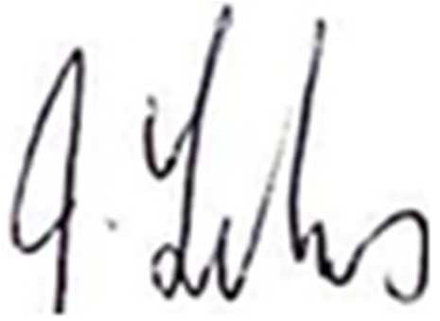

Jim Felvus Manager Vehicle Operations

14 November, 2017
DoT Reference No : 46-2017-1837 GPO Box R1290 Perth, Western Australia, 6844 Issued 14 November 2017 Telephone: 13 11 56 Fax: 1300 669 995
Page 3 of 3 www.transport.wa.gov.au/dvs ABN 27 285 643 255

